Week 3
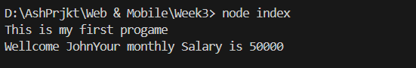
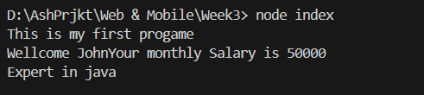
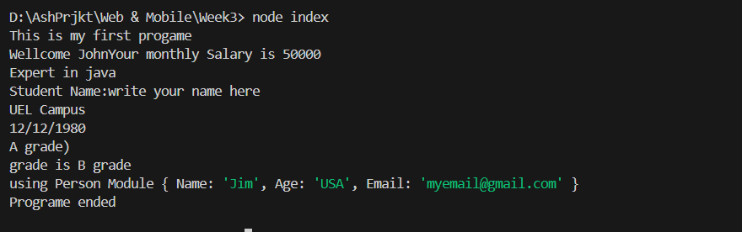
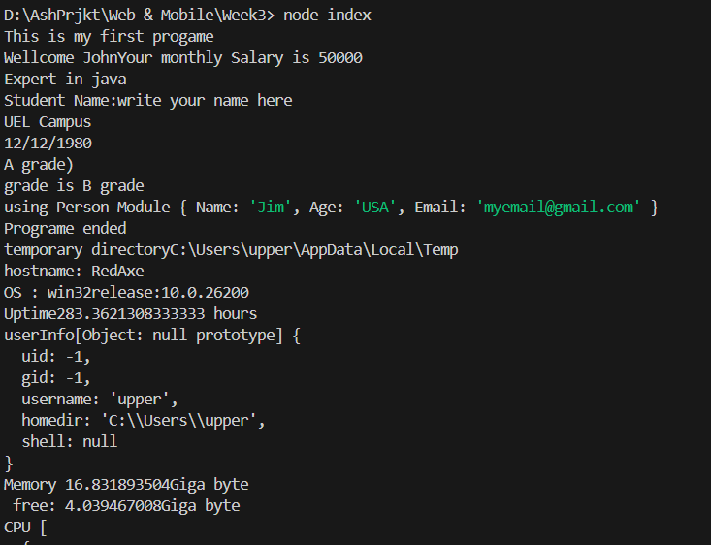
In Week 2, I learned how to create and use functions and modules in JavaScript using Node.js. I wrote simple functions and arrow functions, then created separate module files like StudentInfo.js and Person.js to export and import data between files using the require keyword. I also learned how to use Node.js core modules, such as the os module, to display information about my computer like memory, CPU, and system uptime. At first, it was a bit confusing to link different files together, but I understood.

